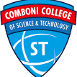

**Comboni college of science & technology**

**Department of computer science**

**PROPOSAL OF MYCETOMA CALL CENTER (MCC).**

**Proposed by:**

**Alzelal Ahmed**

**Levi John Okot**

**Supervised by:**

**Dr. Haythem Abdulmonaim**

**Jan 2023**

***1- Introduction***

**1.1.1 *Background of the study***

Mycetoma is endemic in many tropical and subtropical regions but is reported worldwide. It affects the poorest of the poor in poor, remote communities. The affected populations have low socioeconomic status, low health education levels, and limited access to medical and health care and medication leading to the late presentation of the affected patients with advanced disease. Furthermore, the painless nature of the disease and its physical deformities, disabilities, and social stigma complicate the patients' treatment progress and outcome. The available treatment options for myelomas are inadequate, have many side effects, toxic, expensive, and not available or accessible by most patients. Presently there is no control or prevention programmed for mycetoma, and hence early active case detection and management are the only available tools to reduce the disease burden.

Isolated mycetoma patients in non-endemic regions face more neglect due to the lack of the care providers’ medical experience in dealing with such disease and diagnostic facilities to confirm the diagnosis. Non-governmental organizations picked up many patients in isolated rural areas, conflict zones, and informal settlements, and they were difficult to manage due to a lack of experience in dealing with them.

Health communication centers were established by many medical and health institutes to provide better communication services to support patients and families during their illness journey. They had reduced many diseases’ socioeconomic burdens by considering the patient's far geographical distance, addressing the common health-related problems facing the target population, and designing the most appropriate solutions.

The Mycetoma Research Center (MRC) is dedicated to providing excellent medical and health care for patients in remote villages to reduce the disease socioeconomic burden on these patients and families. Also, it receives many calls and messages concerning overseas suspected patients for medical consultation. With this background, the Mycetoma Call Center was established at the MRC.

***1.1.2 Site of the project***

MYCETOMA RESEARCH CENTER

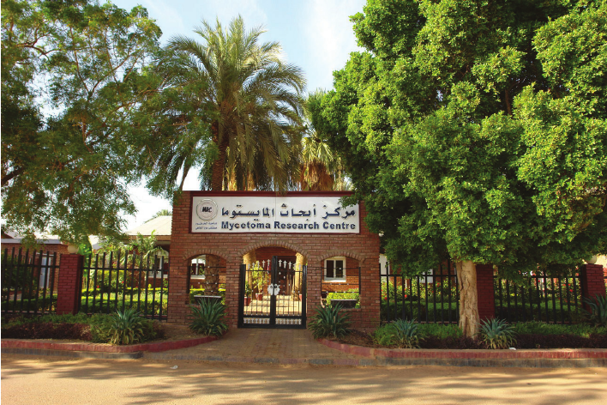

**1.*2 Problem statement***

**1.2.1 General problem**

Both doctors and patient, patients had a hard time to find doctors, and lost trust and interest to find medicine.

It is difficult for patients to find a specific hospital or center to communicate with them to know mycetoma diagnosis and treatment.

**1.2.2 Specific problem**

* The information is not specified to patients and doctors.
* Newly discovered all persons (medical field, community, and patient) having enive information about this disuse.
* Characterized by the development of large subcutaneous messes and discharging.
* Mycetoma is a common medical and health problem in many tropical.
* NO web application can be providing a solution to these points.

**1.3 *Objective Statement***

**1.3.1 General Objectives: -**

The main objective of the Mycetoma Call center (MCC) is to provide authenticated, quick medical and health advice to any person in need to help in the management of suspected mycetoma patients and support those on medical treatment.

**1.3.2 Specific objectives: -**

The MCC can provide different services that include:

1. To design modules that allow communication between patients and rural hospitals through phone, Email, or videoconferencing.
2. To develop a module telemedicine for overseas patients through the internet and videoconferencing.
3. Overseas patients can be intending to be treated at the MRC logistic support

**1.*4 Significance of the project: -***

For the patients, the project provides them with their needed solutions based on previous objectives.

And for the Mycetoma Call center, the application project will be a direct linker to the patient.

For the doctors, the project gives them full knowledge and experience on how to solve problems. And researcher can benefit from this project based on the previous studies.

**1-*5 Scope and Limitations:* -**

**1.5.1 Scope: -**

For both Mycetoma Call centers doctors and Patients, services include:

Registration:

Login:

Video call:

Teleconsultation:

Appointment:

Accept/Reject appointment:

Diagnosis patents

Delete Update, Add, Upload, and Data diagnosis.

Patients can use the system to find, view, and select different types of doctors or medical. Feedback to call stuff.

Report Generation for Admin.

**1.5.2 Limitations**

The Application will not support online payment.

The Application will work only with (MRC).